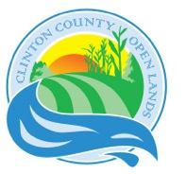
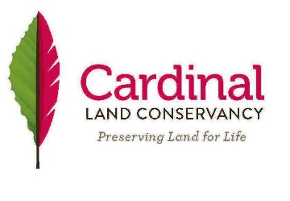
Molting (merging!) into a beautiful bird….

2016 EARTH DAY DINNER

Hosted by Clinton Co. Open Lands and Cardinal Land Conservancy, Inc.

Saturday, April 23, 2016 -- 5:30 Social, 6 p.m. Dinner
Wilmington City Building Community Room
1st Floor – 69 N. South Street, Wilmington, OH 45177

SPEAKER: Solomon Gamboa on “Pollinators and You – Why Pollinators are important and what you can do to help them thrive.”

Non-members - Adults - $20, 12 & U - $10
Members of CCOL/Cardinal – Adults - $17, 12 & U - $10

Catering by Shoelaces
Chicken Cordon Bleu
Red potatoes - roasted
Spinach salad with dressing
Penne with spinach, mushrooms & tomatoes
Selection of pies, drinks

********************* cut here ********** cut here ***************

RESERVATION FORM - 2016 EARTH DAY DINNER – Postmark by April 12.
Early reservations help us with ordering the right amount of food.

NAMES: ___________________________________________________________________________

ADDRESS: ________________________________________________________________________

EMAIL: ___________________________________________ Tel. ___________________________

________ Adults x $20 or $17 = __________
Complete form and mail with check to:
CCOL
P.O. Box 95
Wilmington, OH 45177
________12&U x $10 = __________

